System Prompt Setup
- App Content
AI-Powered Product Recommendation & Marketing Engine for Small Businesses

1.1 Overview
This project designs an AI-powered assistant that helps small retail businesses create effective product bundles and promotional messaging based on their inventory data. The system focuses specifically on bundle recommendation, bundle pricing validation, and marketing content generation.
Rather than building a full e-commerce platform, this project explores how systematic prompt engineering can guide a language model to make structured, business-relevant decisions using the same inventory dataset.
1.2 Problem Background
Small businesses often miss opportunities to increase average order value because complementary products are not bundled strategically. At the same time, pricing decisions are often made intuitively rather than analytically, and promotional content may lack consistency or clarity.
Without structured tools, business owners must manually:
- Identify products that work well together.
- Calculate bundle pricing and discounts.
- Ensure profit margins remain healthy.
- Create marketing copy for promotions.
This process is time-consuming and inconsistent, especially as inventory grows.

1.3 Proposed Solution

The proposed system takes structured inventory data (product name, price, stock level, category) as input and generates:
- Complementary Product Bundles

The system identifies products that logically work well together based on function, theme, or customer experience. Bundles are designed to increase value while remaining realistic for small retailers.
- Bundle Pricing with Margin Consideration
For each bundle, the system calculates:
- Total individual price
- Discounted bundle price (minimum 10% savings)
- Estimated margin based on cost assumptions
- Clear pricing justification
This ensures bundles are attractive to customers while remaining profitable.

3） Marketing Messaging
For each recommended bundle, the system generates:
- Bundle name
- Tagline
- Short promotional blurb
The tone is aligned with the bundle theme (e.g., wellness, cozy home, gifting).
1.4 Prompt Engineering Approach
The same bundling task is tested using multiple prompting strategies to evaluate how prompt structure affects output quality, reasoning clarity, and consistency.
Foundational techniques include:
- Zero-shot prompting
- Few-shot prompting
- Chain-of-thought reasoning
- Stepback and analogical prompting
- Auto-CoT and generate-knowledge prompting
Advanced techniques include:
- Decomposition of sub-tasks
- Ensembling multiple variations
- Self-consistency comparison across runs
- Universal self-consistency for final selection
- Self-criticism and refinement
All techniques operate on the same inventory scenario to allow direct comparison of output differences.
1.5 Goal of the Project
The main goal is not only to generate bundles, but to understand:
- How different prompt structures influence reasoning depth
- How stable the outputs are across multiple runs
- Which techniques improve clarity and robustness
- Which approaches are practical for production use
The project emphasizes structured evaluation and learning from prompt design rather than simply producing a final answer.
1.6 Expected Outcome
The final result is a prompt-engineered bundle recommendation assistant that demonstrates:
- Structured decision-making
- Transparent pricing logic
- Consistent marketing output
- Improved robustness through advanced prompting techniques
More importantly, the project documents how the system prompt evolves from a simple baseline to a more reliable and production-ready version.
- Method
2.1 Experimental Environment
All experiments were conducted in a Jupyter Notebook using the OpenAI Responses API. A helper function (run_prompt) was created to standardize model calls, ensuring that each prompting technique used the same model configuration and input structure.
The same inventory dataset was used across all experiments. The inventory included product name, price, stock level, and category information. Keeping the dataset fixed allowed us to isolate the effect of prompt structure on output quality, rather than differences caused by changing inputs.
All prompts were executed using the same base model to maintain consistency and comparability.
2.2 Task Definition
The core task remained constant throughout the notebook:
- Recommend product bundles from the given inventory
- Suggest pricing strategies (sometimes with explicit savings constraints)
- Generate short marketing messaging
By holding the task constant and only modifying prompt structure, we were able to observe how different prompting techniques influenced reasoning depth, clarity, creativity, and reliability.
2.3 Foundational Prompting Setup
Three foundational prompting techniques were tested first:
  - Zero-Shot Prompting
The model was given a direct instruction to recommend bundles, pricing, and taglines with no examples or structured reasoning steps. This served as the baseline output.
  - Few-Shot Prompting
Example bundle recommendations were provided before the task instruction. These examples established a specific output format (products, bundle name, price with savings, tagline). The model was then asked to generate similar bundles using the inventory dataset.
  - Chain-of-Thought Prompting
The model was explicitly instructed to reason step by step before providing final recommendations. The reasoning steps included identifying complementary products, checking stock levels, calculating minimum 10% savings, defining target customers, and generating taglines.
All three foundational methods were applied to the same inventory and task, enabling direct comparison.
2.4 Advanced Prompting Setup
After evaluating baseline performance, advanced techniques were applied to improve robustness and reliability.
- Stepback Prompting: The model first articulated general principles of effective bundling before applying them to the inventory.
- Analogical Prompting: The model used a fast-food value meal analogy to structure bundle recommendations.
- Auto-CoT: The model generated its own guiding questions before answering them.
- Generate-Knowledge Prompting: The model listed relevant consumer behavior and pricing insights before producing recommendations.
- Decomposition: The task was split into smaller sub-tasks (identify complementary products, calculate pricing, generate marketing content).
- Ensembling: Multiple expert-style prompts were run and then synthesized into final recommendations.
- Self-Consistency: The same prompt was executed three times, and the most consistent recommendation was selected.
- Universal Self-Consistency: The model generated multiple bundle options and selected the strongest one itself.
- Self-Criticism: An initial recommendation was critiqued and then revised to address identified weaknesses.
2.5 Evaluation Criteria
Outputs were evaluated based on:
- Clarity – Was reasoning structured and understandable?
- Commercial Practicality – Were bundles realistic and financially sensible?
- Consistency – Did repeated runs produce similar results?
- Development Effort – How much prompt engineering was required to achieve stable output?
The goal was not simply to produce the best bundle, but to understand how prompt design affects output quality, reasoning transparency, and reliability.
- Foundational Prompting Experiments
All foundational techniques were applied to the same inventory dataset and executed using the same model configuration. This ensured that differences in output were caused by prompt structure rather than changes in task or data.
  - Zero-Shot Prompting
Prompt Used
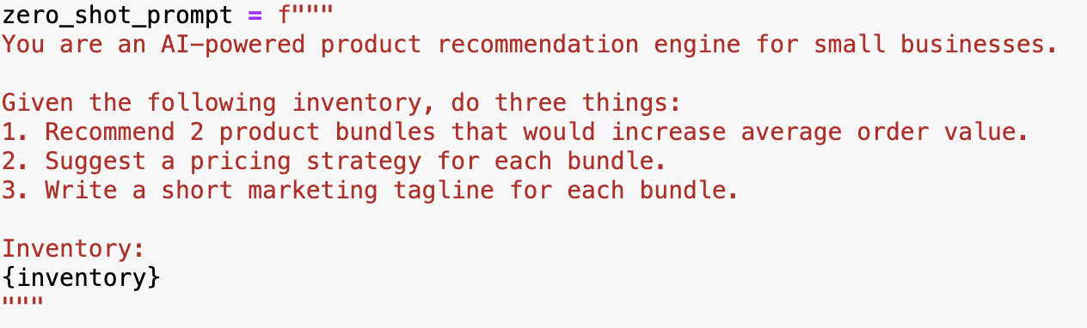
Output
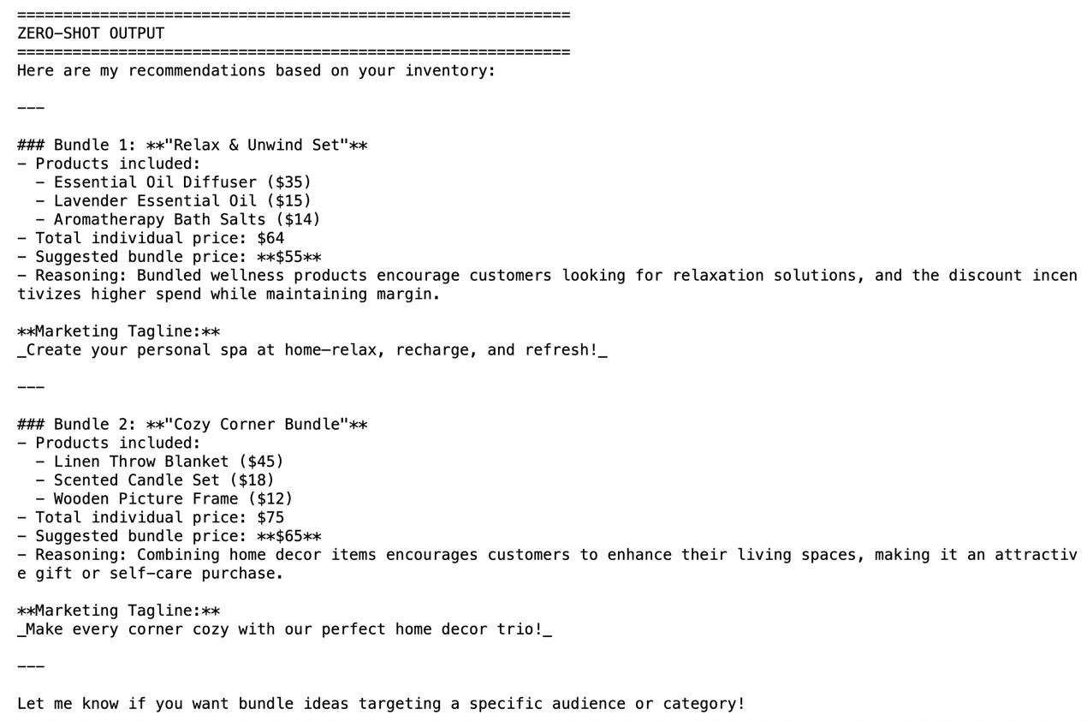
Analysis
The zero-shot output served as the baseline performance of the model without structured guidance or examples.
Observations:
- The model successfully generated two bundles with pricing and taglines.
- Complementarity was generally logical but not always justified explicitly.
- Pricing strategies were described at a high level rather than calculated precisely.
- There was no explicit requirement for savings percentage or margin validation.
- Reasoning behind bundle choices was implicit rather than structured.
Overall, zero-shot prompting demonstrated that the model can produce commercially reasonable recommendations without additional scaffolding. However, the lack of explicit reasoning and constraints led to variability in structure and depth.
  - Few-Shot Prompting
Prompt Used
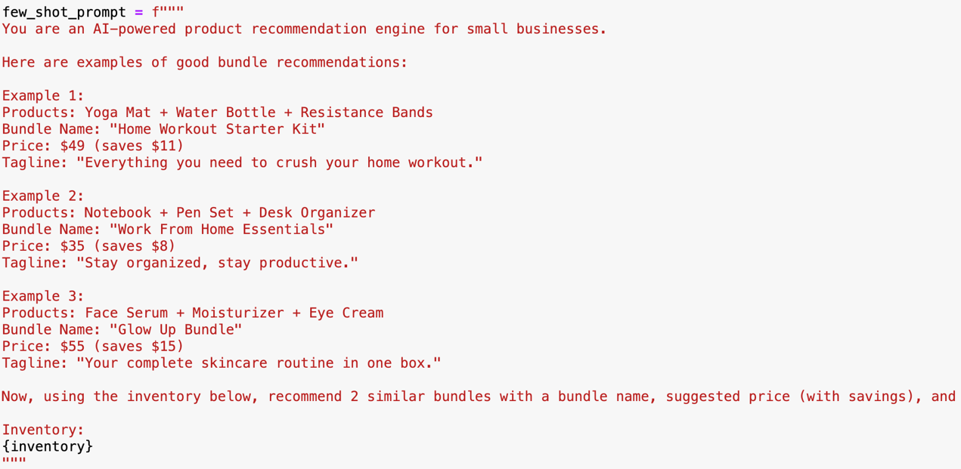
Output
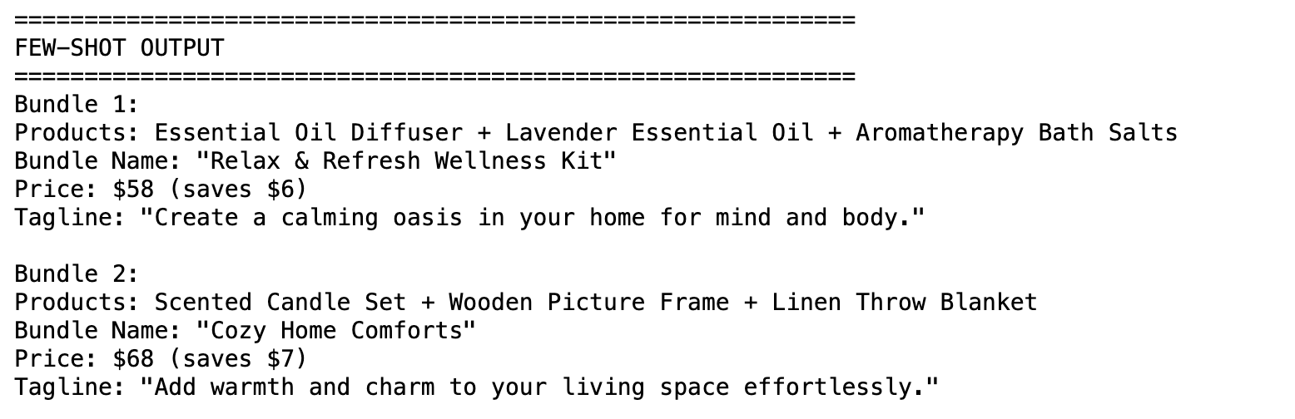Analysis
Providing structured examples significantly influenced output formatting and presentation.
Observations:
- The model followed the example format closely (Products, Bundle Name, Price with savings, Tagline).
- Pricing now consistently included explicit “saves $X” statements.
- Bundles tended to follow the 3-product structure shown in examples.
- Marketing tone became more polished and consumer-facing.
- However, reasoning and pricing logic were not explicitly explained.
Few-shot prompting improved consistency and readability but constrained output flexibility. The model prioritized matching the example structure over deeper justification.
  - Chain-of-Thought (CoT) Prompting
Prompt Used
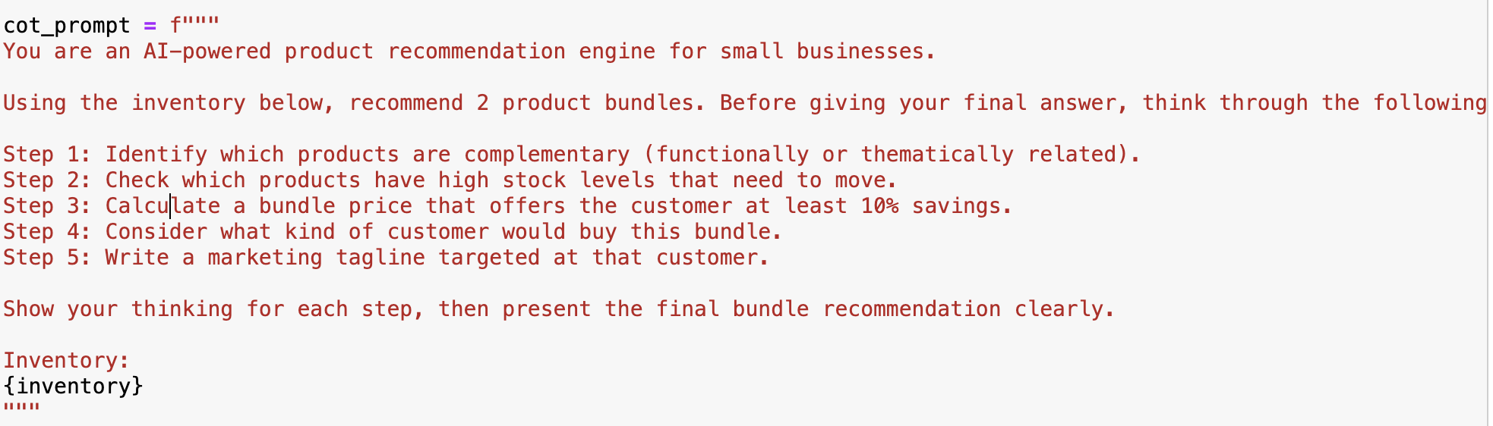
Output
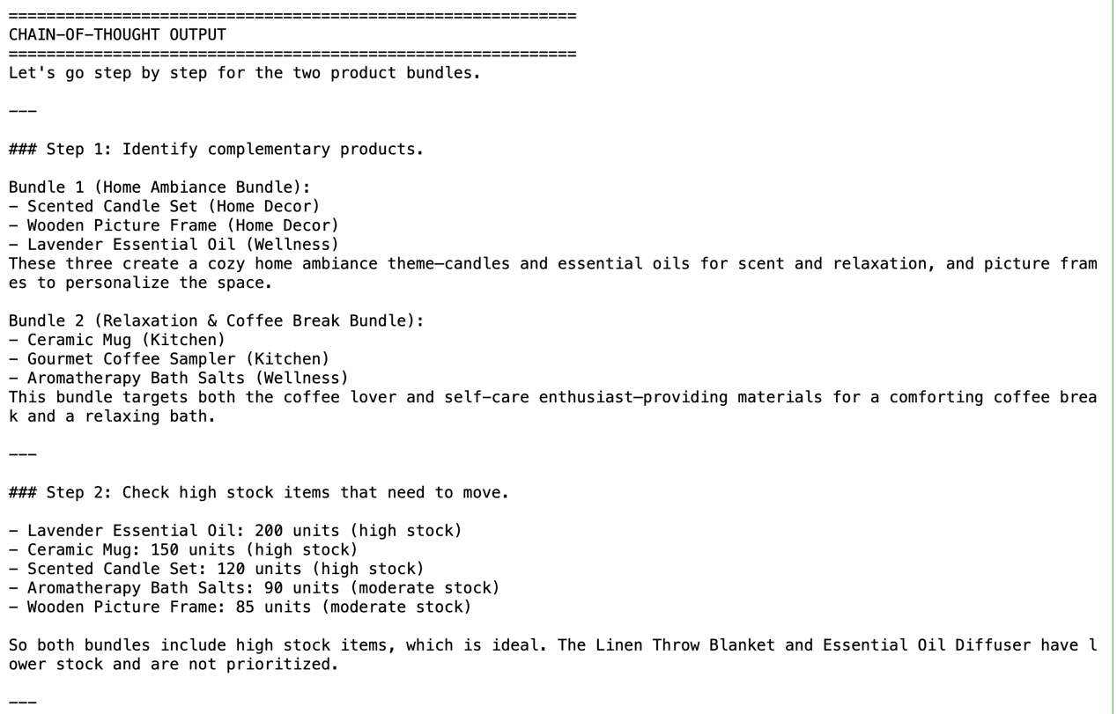
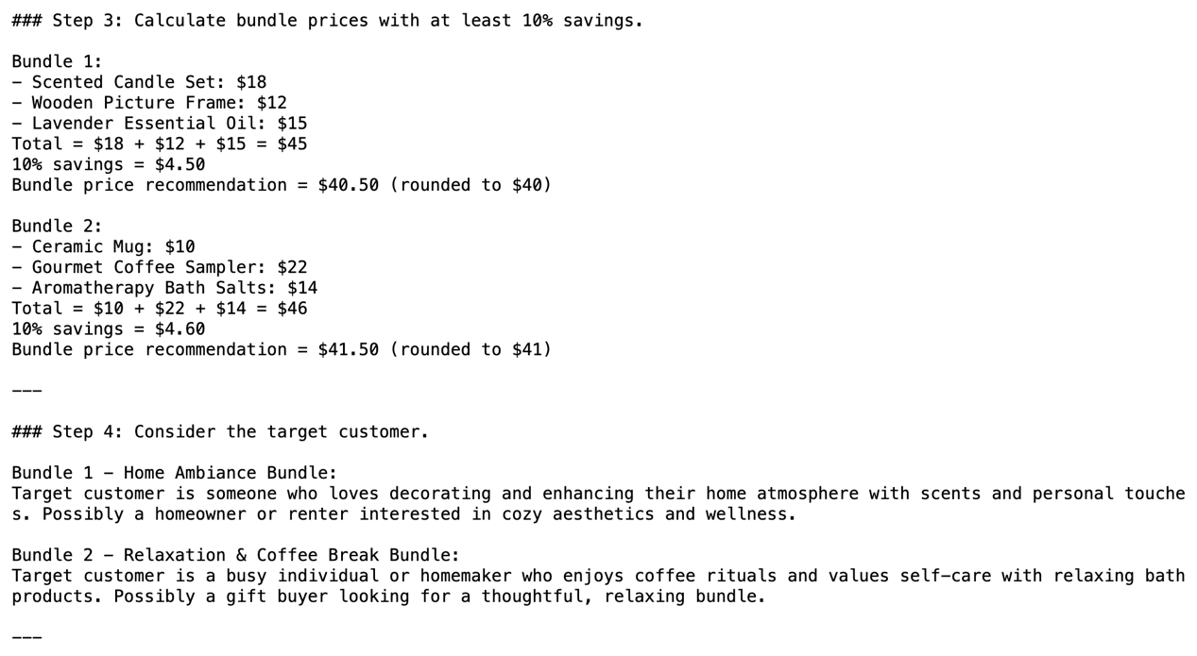
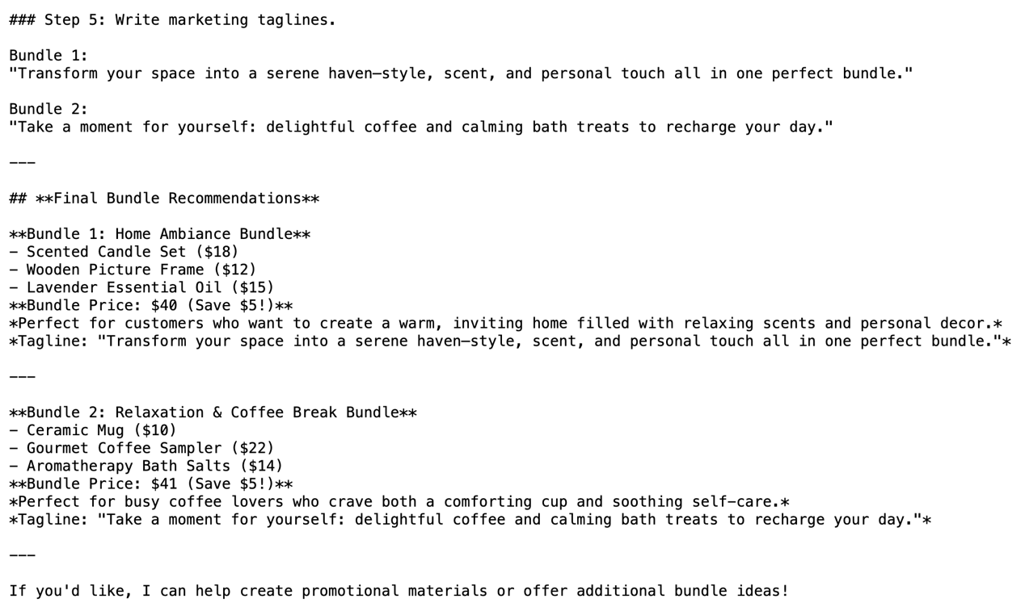Analysis
Chain-of-Thought prompting significantly increased transparency and structure.
Observations:
- The model explicitly walked through complementarity, stock levels, pricing calculations, and customer targeting.
- Bundle pricing included clear minimum 10% savings calculations.
- Recommendations were more grounded in inventory constraints.
- Marketing taglines were better aligned with identified target customers.
- Output length increased due to visible reasoning steps.
Compared to zero-shot and few-shot, CoT produced more defensible and commercially realistic bundles. The reasoning process was traceable and easier to evaluate. However, it required more prompt engineering effort and resulted in longer outputs.
3.4 Foundational Comparison Summary
Across the three techniques:
- Zero-shot demonstrated baseline capability but lacked structured reasoning.
- Few-shot improved format consistency and marketing polish but did not deepen logic.
- Chain-of-Thought provided the strongest justification and constraint adherence, especially regarding pricing and inventory considerations.
These experiments established the foundation for applying advanced techniques aimed at improving robustness and reliability.
- Advanced Experiments
After evaluating foundational prompting techniques, we introduced advanced strategies to improve three key dimensions:
- Reasoning Structure
- Output Robustness
- Iterative Refinement
Rather than optimizing only creativity, these techniques focused on reliability, defensibility, and production-readiness.
  - Improving Reasoning Structure
Techniques Used
- Stepback
- Generate-Knowledge
- Decomposition
These techniques aimed to improve how the model reasons before generating final bundle recommendations.
Key Observations
- Stepback improved conceptual grounding by requiring the model to articulate bundling principles before applying them.
- Generate-Knowledge activated relevant domain knowledge about consumer behavior and pricing psychology.
- Decomposition had the strongest structural impact by breaking the task into sub-tasks:
  - Identify complementary products
  - Calculate pricing with ≥10% savings
  - Generate marketing content
Among these, Decomposition produced the most controlled and commercially defensible output, particularly in pricing logic.
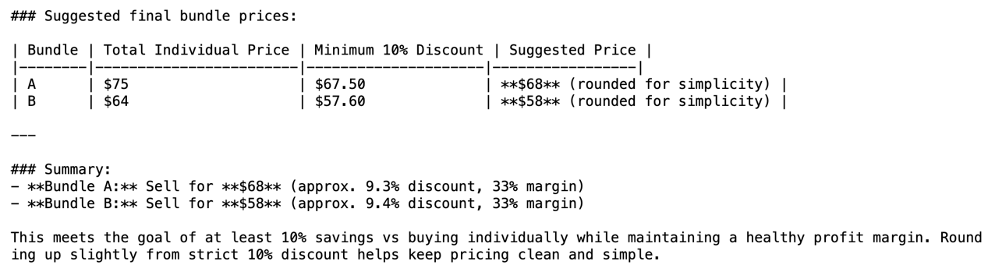
Figure 1. Decomposition pricing calculation showing explicit savings logic.
  - Increasing Output Robustness
Techniques Used
- Ensembling
- Self-Consistency
- Universal Self-Consistency
These methods aimed to reduce randomness and improve recommendation reliability.
Key Observations
- Ensembling generated bundles from multiple perspectives (creative, data-driven, customer-experience), then synthesized them into a more balanced final recommendation.
- Self-Consistency reduced variance by running the same prompt three times and selecting the most recurring bundle idea.
- Universal Self-Consistency allowed the model to generate multiple themed bundles and evaluate them internally before selecting the strongest option.
These techniques improved confidence in the final recommendation by filtering variability.
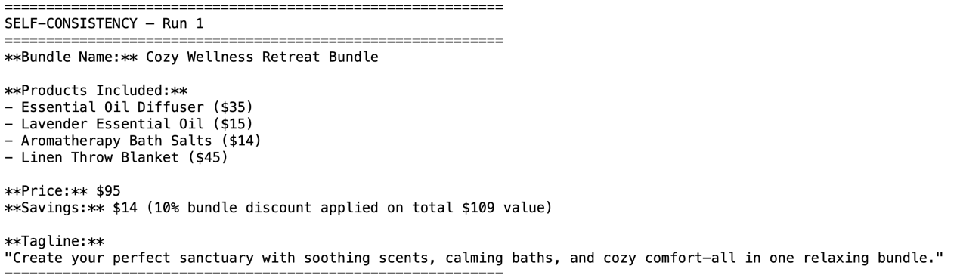
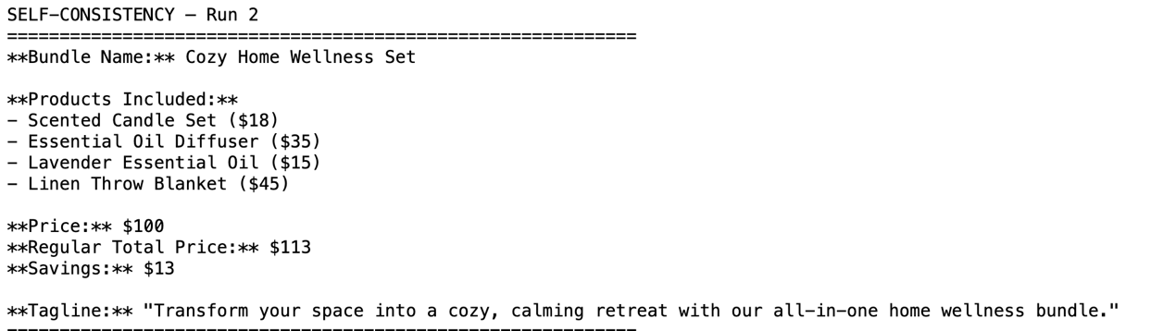
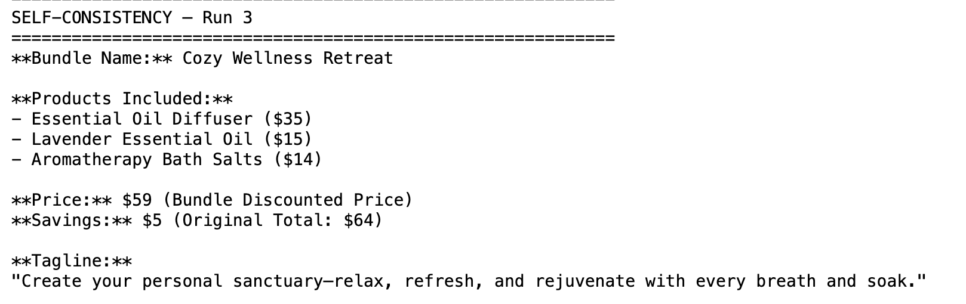
Figure 2. Three independent runs of the same prompt showing variation in bundle composition.
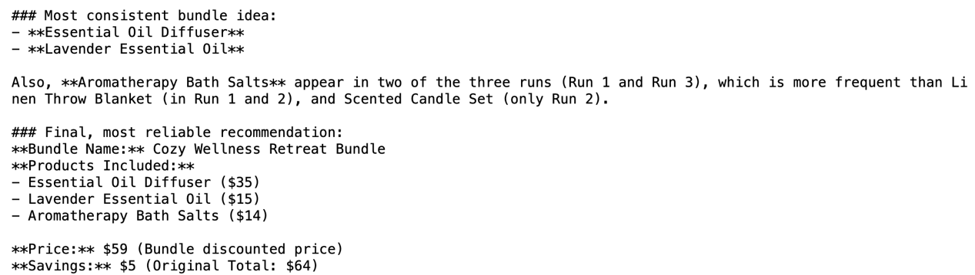
Figure 3. Final selection based on product frequency analysis across runs.
  - Enabling Iterative Refinement
Technique Used
- Self-Criticism
This method introduced a structured improvement loop:
- Generate initial recommendation
- Critically evaluate weaknesses
- Revise based on critique
Key Observations
Self-Criticism produced the clearest quality improvement.
Common weaknesses identified included:
- Weak complementarity justification
- Vague pricing logic
- Generic marketing language
The revised output addressed these issues explicitly, resulting in stronger reasoning and more persuasive messaging.
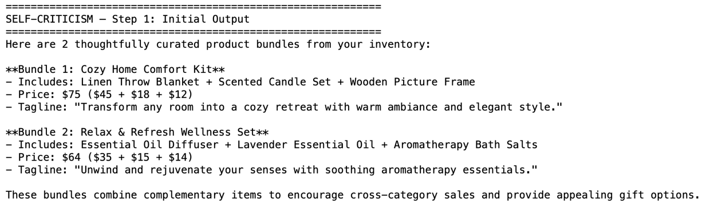
Figure 4. Initial bundle recommendation.
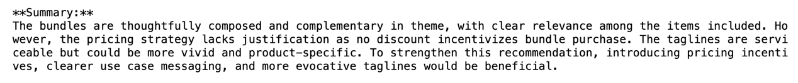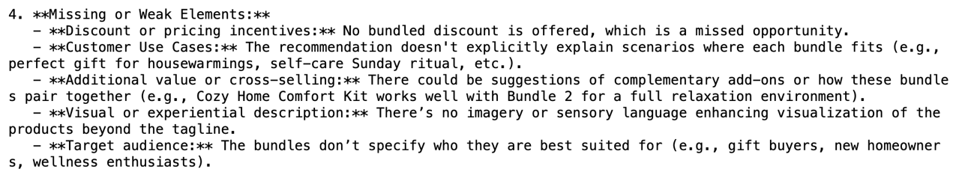
Figure 5. Critique section highlighting weaknesses.
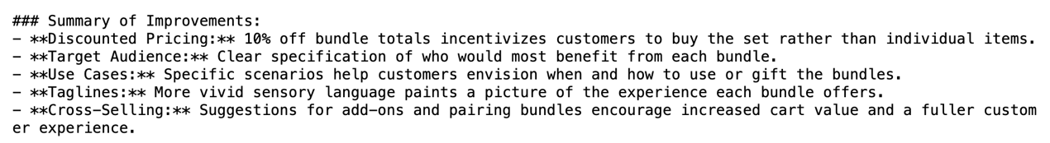
Figure 6. Improved final bundle.
4.4 Advanced Experiments Summary
Across all advanced techniques:
- Decomposition improved structural clarity and pricing defensibility.
- Self-Consistency improved reliability across runs.
- Self-Criticism enabled visible iterative improvement.
- Ensembling enhanced diversity and balance of ideas.
- Stepback and Generate-Knowledge strengthened conceptual grounding but had less dramatic impact on final structure.
Overall, advanced prompting shifted the system from simple recommendation generation to a more structured and reliable decision-support workflow.
- Prompt Evolution: From Initial to Advanced System Prompt
Our system prompt evolved in stages as we observed the model’s behavior across experiments. The evolution was not about making the prompt longer, but about making it more structured, reliable, and aligned with real business constraints.
5.1 Initial System Prompt
The initial system prompt positioned the model as:
“An AI-powered product recommendation engine for small businesses.”
At this stage, the prompt primarily focused on:
- Generating 2 bundles
- Suggesting pricing
- Writing marketing taglines
The model was given the inventory and a task, but no explicit reasoning structure or operational constraints.
This version was sufficient for producing plausible bundle ideas. However, we observed several limitations:
- Pricing lacked explicit savings calculations
- Complementarity was not always justified
- Marketing language was sometimes generic
- Outputs varied across runs
The system behaved creatively, but not consistently or defensibly.
5.2 Structured Reasoning Enhancements
To address these issues, we incorporated structured prompting techniques into the system behavior.
Chain-of-Thought introduced step-by-step reasoning:
- Identify complementary products
- Check stock levels
- Calculate ≥10% savings
- Define target customer
This shifted the system from “generate bundles” to “reason about bundles.”
Decomposition further strengthened this by splitting the task into:
- Complementarity analysis
- Pricing calculation
- Marketing generation
This significantly improved pricing defensibility and clarity.
At this stage, the system prompt implicitly evolved into:
A recommendation engine that reasons through complementarity, pricing constraints, and customer targeting before producing output.
5.3 Robustness and Reliability Enhancements
We then focused on reducing output variance and improving reliability.
Self-Consistency introduced multiple independent runs and frequency analysis, allowing us to select bundles that appeared most consistently.
Universal Self-Consistency enabled the model to generate multiple themed bundles and evaluate them internally.
Ensembling combined different expert perspectives (creative, analytical, experiential), resulting in more balanced final outputs.
The system was no longer just generating bundles—it was filtering and validating them.
5.4 Iterative Improvement via Self-Criticism
Finally, we introduced a critique-and-revise loop.
The system:
- Generated initial bundles
- Identified weaknesses (e.g., missing discount, vague target audience)
- Produced an improved version
This made the system more production-ready. The improved bundles showed:
- Clear discount logic
- Defined target segments
- Stronger experiential language
- Cross-sell suggestions
This step transformed the system from a generator into a self-improving decision assistant.
5.5 Final Advanced System Behavior
By the end of experimentation, the effective system prompt implicitly required the model to:
- Consider complementarity and stock levels
- Enforce minimum savings constraints
- Maintain profit margin awareness
- Target specific customer personas
- Provide marketing-ready messaging
- Validate consistency across runs
- Improve itself through critique
The evolution reflects a shift from basic content generation to structured, reliable recommendation engineering.
- Reflection on Prompt Effectiveness
This project showed that prompt design is not just about asking better questions — it is about shaping how the model thinks.
At the foundational level, zero-shot prompting demonstrated that the model can generate reasonable bundle ideas with minimal instruction. However, the outputs were sometimes inconsistent, lacked explicit pricing logic, and did not always justify why the products were grouped together. Few-shot prompting improved formatting and clarity by providing structured examples. The model followed the example structure closely, producing clearer bundle names, savings statements, and taglines. This showed how examples act as a behavioral guide rather than just additional context.
Chain-of-thought had a much stronger impact. By explicitly requiring step-by-step reasoning — identifying complementary products, checking stock levels, calculating savings, and defining customer segments — the model produced more defensible and logically structured bundles. The reasoning process made the recommendations easier to validate and more aligned with business constraints. Compared to zero-shot outputs, the CoT responses were more transparent and practically useful.
Among the advanced techniques, decomposition and self-criticism were the most impactful. Decomposition improved structural precision by separating complementarity analysis, pricing calculation, and marketing content. This prevented the model from blending creative and analytical tasks in a single step, resulting in clearer pricing logic and more controlled outputs. Self-criticism introduced iterative refinement. The critique phase exposed weaknesses such as missing discounts or vague audience targeting, and the revised output clearly addressed those gaps. This demonstrated that structured iteration can significantly enhance quality.
Self-consistency and ensembling improved reliability rather than creativity. Running the same prompt multiple times revealed variability, but also showed recurring patterns (e.g., wellness-oriented bundles). Selecting the most consistent recommendation increased confidence in the final output. Ensembling combined different perspectives, resulting in more balanced bundles that considered both creativity and revenue optimization.
Overall, the most effective combination was chain-of-thought for reasoning clarity, decomposition for structural control, and self-criticism for refinement. Few-shot prompting was the easiest to implement and produced immediate improvements in formatting and presentation. However, structured reasoning techniques had a greater impact on output robustness and real-world usability.
This project highlighted that effective prompt engineering is less about clever wording and more about introducing structure, constraints, and evaluation loops. By layering examples, step-by-step reasoning, decomposition, and self-evaluation, the system evolved from generating plausible bundles to producing consistent, defensible, and production-ready recommendations.

